**Java Task**

1.

package project1;

public class Person {

private String name;

private int age;

public Person(String name, int age) {

this.name = name;

this.age = age;

}

public String getName() {

return name;

}

public int getAge() {

return age;

}

public static void main(String[] args) {

Person person = new Person("Alice", 25);

System.***out***.println("Name: " + person.getName());

System.***out***.println("Age: " + person.getAge());

}

}

OUTPUT:

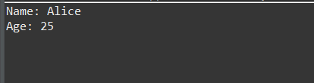

2.

package project1;

public class Employee {

private int id;

private String firstName;

private String lastName;

private int salary;

public Employee(int id, String firstName, String lastName, int salary) {

this.id = id;

this.firstName = firstName;

this.lastName = lastName;

this.salary = salary;

}

public int getID() {

return id;

}

public String getFirstName() {

return firstName;

}

public String getLastName() {

return lastName;

}

public String getName() {

return firstName + " " + lastName;

}

public int getSalary() {

return salary;

}

public void setSalary(int salary) {

this.salary = salary;

}

public int getAnnualSalary() {

return salary * 12;

}

public int raiseSalary(int percent) {

salary += salary * percent / 100;

return salary;

}

*@Override*

public String toString() {

return "Employee [id=" + id + ", name=" + getName() + ", salary=" + salary + "]";

}

public static void main(String[] args) {

Employee emp = new Employee(1, "John", "Doe", 5000);

System.***out***.println(emp);

System.***out***.println("ID: " + emp.getID());

System.***out***.println("First Name: " + emp.getFirstName());

System.***out***.println("Name: " + emp.getName());

System.***out***.println("Salary: " + emp.getSalary());

System.***out***.println("Annual Salary: " + emp.getAnnualSalary());

System.***out***.println("New Salary after 10% raise: " + emp.raiseSalary(10));

System.***out***.println(emp);

}

}

OUTPUT:

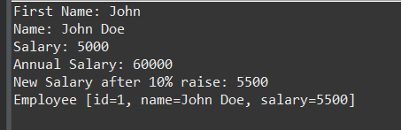

3.

package project1;

public class Circle {

private double radius;

public Circle() {

this.radius = 1.0;

}

public Circle(double radius) {

this.radius = radius;

}

public double getCircumference() {

return 2 * Math.***PI*** * radius;

}

public double getRadius() {

return radius;

}

public void setRadius(double radius) {

this.radius = radius;

}

public static void main(String[] args) {

Circle circle1 = new Circle();

System.***out***.println("Circle1 (default radius):");

System.***out***.println("Radius: " + circle1.getRadius());

System.***out***.println("Circumference: " + circle1.getCircumference());

Circle circle2 = new Circle(5.0);

System.***out***.println("\nCircle2 (radius = 5.0):");

System.***out***.println("Radius: " + circle2.getRadius());

System.***out***.println("Circumference: " + circle2.getCircumference());

}

}

OUTPUT:

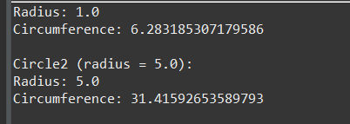

4.

package project1;

public class Account {

private String accountNumber;

private double balance;

public Account() {

this.accountNumber = "000000";

this.balance = 0.0;

}

public Account(String accountNumber, double initialBalance) {

this.accountNumber = accountNumber;

this.balance = initialBalance;

}

public void deposit(double amount) {

if (amount > 0) {

balance += amount;

System.***out***.println("Deposited: $" + amount);

} else {

System.***out***.println("Deposit amount must be positive.");

}

}

public void withdraw(double amount) {

if (amount > 0 && amount <= balance) {

balance -= amount;

System.***out***.println("Withdrew: $" + amount);

} else if (amount > balance) {

System.***out***.println("Insufficient balance.");

} else {

System.***out***.println("Withdrawal amount must be positive.");

}

}

public double checkBalance() {

return balance;

}

public static void main(String[] args) {

Account account1 = new Account();

System.***out***.println("Account1 (default):");

System.***out***.println("Balance: $" + account1.checkBalance());

Account account2 = new Account("123456", 1000.0);

System.***out***.println("\nAccount2 (initialized with $1000):");

System.***out***.println("Balance: $" + account2.checkBalance());

account2.deposit(500);

System.***out***.println("New Balance: $" + account2.checkBalance());

account2.withdraw(200);

System.***out***.println("New Balance: $" + account2.checkBalance());

account2.withdraw(1500);

}

}

OUTPUT:

